PSSI Science Project Reporting Template

️ | The PSSI Implementation Team is compiling a technical report to demonstrate the important research and advancements made by the Science Branch through the PSSI funding. The technical report will include a 3-4 page summary (including graphics and figures) for each project to show their key results and findings. Please fill in the following fields and sections for your project to be included in the report. Feel free to include and draw from any reports or presentations previously created through your research.  A plain language science bulletin will also be created to follow up on last year’s “DFO Pacific Region Science Bulletin, 2024. New research and monitoring for Pacific salmon and their ecosystems.” While the first bulletin introduced project backgrounds, methods, and timelines, this new bulletin will highlight the projects’ results, key findings, and conclusions with links to reports and data available. The bulletin will include a 1-2 page summary for each project gleaned from the content entered below.  ️ Completed forms are due January 7, 2026.  *Please include or send separately any graphics or pictures (with photo credits) that will help promote the projects.

PART 1: PROJECT METADATA

General Project Information
Project ID (number) | Project Title
2424 | Mechanistic modelling to link hydrology to juvenile salmon habitat quality and productivity
Project Leads | Collaborations and External Partners
Sean Naman | Doug Braun  Josephine Iacarella  Secwépemc Fisheries Commission
Location (if applicable)
Click or tap here to enter text.

Geographic and Stock Information
Salmon species (if applicable) | Waterbodies (if applicable)
Coho | North Thompson
Life history phases (if applicable) | Region
Juvenile | Interior
Stock (if applicable) | Population (if applicable)
Click or tap here to enter text. | Click or tap here to enter text.
Conservation Unit (if applicable)
Click or tap here to enter text.

🧰 PART 2: PROJECT METRICS

Project Outputs
Include any anticipated outputs denoted as (in progress). Please include links to any outputs available online so they can be referenced in the report.
List scientific publications and technical reports (with links)
Naman SM (In review) Temperature dependent habitat suitability curves for instream flow modelling. North American Journal of Fisheries Management

Naman SM, Hnytka SM, Gronsdahl S, McParland D. (In progress) Simulating channel hydraulics using the Geomorphic Instream Flow Tool (GIFT): guidance for model use and interpretation. DFO Technical Report

Hnytka SM, Naman SM, Gronsdahl S, Kuchma S, Sterling J, Martens AM. (In progress). Flow-habitat relationships for coho rearing streams across the North Thompson watershed. DFO Technical Report

Naman SM, Hnytka SM, Gronsdahl S, Martens AM, Iacarella J, Weller D, Braun DC. (In progress). Modelling potential low flow habitat bottlenecks for coho salmon across a large watershed: influences of hydrology, geomorphology, and climate warming. Peer review publication [delayed]

List datasets generated (with links)
Click or tap here to enter text.
Describe dataset locations and data management systems
Click or tap here to enter text.
List code, programs, or other software created (with links)
Click or tap here to enter text.
List communication or social media products
Click or tap here to enter text.
List and describe field work completed
Habitat surveys in 17 streams across North Thompson watershed. Physical habitat information includes: channel slope, substrate size composition, channel cross sections (bankfull elevation and bathymetry).
List and describe samples collected/analyzed (number of samples)
NA
List and describe large capital assets or equipment acquired
NA

PART 3: WRITTEN CONTENT

Highlights
Please summarize in 2-3 bullets:
- The main idea of the project
- Key findings
- Implications of these findings for salmon and decision-makers
- For a more technical audience, but still as plain language as possible
This project developed and applied methods to estimate instream flow needs for juvenile salmonids in a warming climate. Habitat simulation models incorporating temperature were developed in 17 coho rearing tributaries across the North Thompson watershed.

Relationships between flow and rearing habitat availability varied across streams, suggesting that conventional generic low flow thresholds may not be widely applicable. Temperature effects on flow-habitat relationships were also variable, but in some cases suggested higher flows are required if temperatures are warmer.

Model outputs will inform real-time hydrometric monitoring and planning in the North Thompson, but the methods are broadly applicable to other salmon systems where both flow and temperature are of interest.

Background
Please provide 1-2 paragraphs to summarize
- The relevant biological, environmental, and/or management context
- What knowledge gap or demand were you trying to fill?
- Collaboration and partner relationships
Low flows during summer months can be an important bottleneck for stream-rearing rearing salmon. Determining how much water fish need is therefore a critical management question, especially given rising human water use and climate warming. Elevated water temperature is another threat facing stream-rearing salmon that is often linked to low flows. However, conventional modelling tools for determining instream flow needs have generally not explicitly considered temperature. This is a gap for management as it is unclear if current instream flow assessments will apply in a warmer future.

This project developed an analytical framework to integrate water temperature into habitat simulation models, a widely used tool for determining instream flow needs. We used a bioenergetics framework that relates channel hydraulics (e.g., depth and velocity) and temperature to the daily energy balance of juvenile salmonids. We then applied the approach to 17 coho-rearing streams across the North Thompson watershed, interior BC. This work was collaborative with Secwépemc Fisheries Commission and Simpcw First Nation and will inform instream flow management through the lens of climate change.

️ Methods and Findings
Please insert a few paragraphs to summarize:
- Main methods used
- Products and tools produced
- Advancements in methodology, technology, and application
- Advancements in communication and knowledge transfer
- Key results and information generated
We used a habitat simulation model framework that links streamflow to channel hydraulics, then channel hydraulics to fish using bioenergetics. The end result is a matrix of relative habitat availability across combinations of flow and water temperature. This can be used as a tool to support real-time flow and temperature monitoring or be linked to flow and temperature projections under contrasting climate change scenarios. Initial model outputs have been shared with Secwépemc Fisheries Commission to support drought monitoring in several priority systems.

Flow-habitat relationships were variable across the different streams, suggesting that generic thresholds of flow (e.g., 20% of mean annual discharge) may not always apply. The combined effect of flow and temperature was also variable, reflecting the complex nonlinear pathways that temperature influences fish.

While the specific model outputs generated to date are applicable to the North Thompson, the general approach is broadly applicable to other systems where the combined impacts of flow and temperature change are of interest.

Insights
Please insert a few paragraphs to summarize:
- What this project has added to knowledge about salmon populations, health, or ecosystems.
- How this project informs salmon management:
  - decisions
  - policy guidance
  - trade-offs
  - planning
- Addition of knowledge to understanding:
  - limiting factors/stressors/threats/ pathways of effects/risks
  - biologically significant thresholds
  - cumulative impacts
- Sources of uncertainty
Flow and temperature are both critical habitat dimensions for salmon in freshwater, but there is still significant uncertainty in their combined effects on fish. This study provides a framework to integrate temperature into instream flow models, which support a number of management decisions, including regulatory authorizations, watershed planning, and water governance. It is also relevant for cumulative effects, where flow and temperature are common pathways where various activities impact salmon and their ecosystems.

As with any modelling tool, there are simplifications and assumptions that should temper inferences. The approach developed here is intentionally simple and conforms to conventional habitat simulation modelling constraints. This simplicity is a benefit in that it maintains tractability, but a limitation in that the method is subject to many of the longstanding critiques of habitat simulation modelling approaches (see Railsback 2016).

⏩ Next Steps
Please insert 1-2 paragraphs to summarize:
- Remaining knowledge gaps and recommendations for future studies
- How can/should the project findings be operationalized for salmon conservation and management?
Undertaking this work highlighted several important empirical knowledge gaps that should be the focus of future studies. First, there is surprisingly scarce empirical data on how salmonids shift their behaviour and habitat use at high temperatures in the wild. Predictions from our models at high temperatures should therefore be tempered. Second, there is considerable variation in how flow and temperature covary. For instance, low flows are often associated with warming water temperature, but this may not be the case in systems with groundwater influence. Work to better predict these complex dynamics would benefit the application of this modelling tool.

The analytical framework developed from this project is accessible and should be readily available to interested practitioners. Habitat simulation modelling is widely used and the advances from this project can be readily integrated (see Naman et al. 2020). Model outputs can provide a more dynamic perspective on flow needs for fish in a warming climate.

📈 Tables and Figures
Please provide captions and numbering for any tables and figures. Graphics can be copied below or e-mailed separately.
- Include a brief caption with each figure and table in the box below
- Number each table and figure, and include references in the above sections where appropriate.
- 1-3 figures are recommended per project
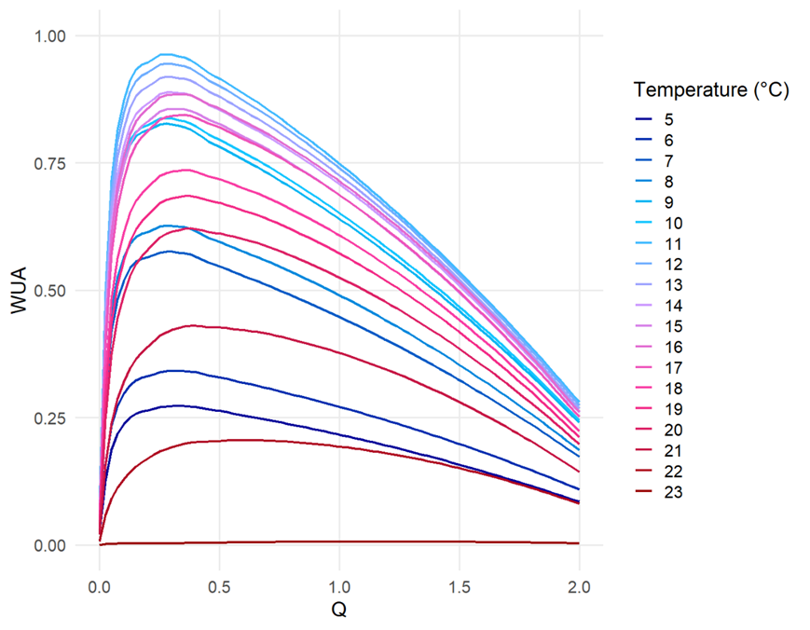
Figure 1. Example model output plotting weighted usable area (WUA), the relative area of suitable rearing habitat, against flow (Q) across different temperatures.

Table 1. Matrix of model predictions of relative area of suitable rearing habitat across combinations of flow and temperatures in a coho rearing stream in the North Thompson watershed. This table supports real-time flow and temperature monitoring during summer baseflow conditions.

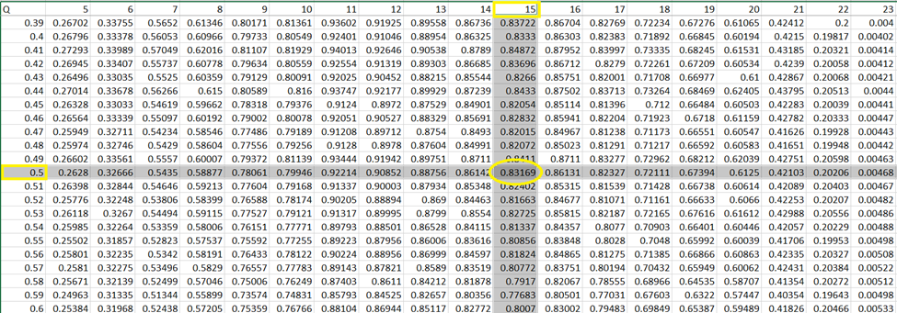

📈 References
Include full references for any publications referenced in other sections. Please format references in Harvard style according to Instructions to Authors for the Canadian Journal of Fisheries and Aquatic Sciences, at Canadian Science Publishing.
Railsback, S.F., 2016. Why it is time to put PHABSIM out to pasture. Fisheries, 41(12), pp.720-725.

Naman, S.M., Rosenfeld, J.S., Neuswanger, J.R., Enders, E.C., Hayes, J.W., Goodwin, E.O., Jowett, I.G. and Eaton, B.C., 2020. Bioenergetic Habitat Suitability Curves for Instream Flow Modeling: Introducing User‐Friendly Software and its Potential Applications. Fisheries, 45(11), pp.605-613.

